STUDENT VOICE NEWSLETTER 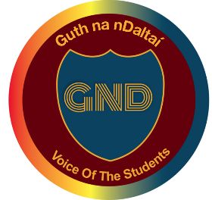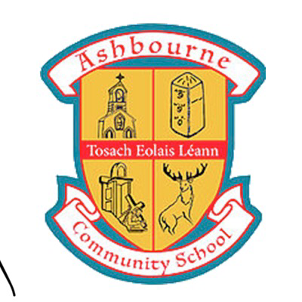

December 2020 ISSUE
A message from this month’s editors
HEAD STUDENTS
Firstly, we would like to take the opportunity to congratulate everybody on another fantastic term here at ACS. There has been an exceptional effort by students to ensure our school remains a safe and friendly environment that we can all thrive in.
Our second Guth na nDaltaí meeting was held on Tuesday 15th December and proved to be very productive. Great ideas were put forward regarding the school uniform, school hygiene and how our school could become even more environmentally friendly, and we would like to thank all those who attended. We have also been looking to revise the menu in the canteen this year to ensure that all students feel catered for and will be looking for student input as to what will be on offer.

The annual Christmas Jumper Day was a huge success again this year, raising €1500 for the Society of St. Vincent de Paul, along with many hampers and gifts donated throughout the month.
There has been immense charitable work done in general this term with TY students raising money in aid of the Irish Cancer Society by holding a socially distanced fun run. A big thanks to everyone who contributed this year.
We also encourage all students to check out the new student website on the Ashbourne Community School page!
We wish everyone a happy and healthy Christmas and look forward to seeing you all in the new year.

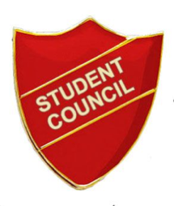  STUDENT COUNCIL  Hi everyone!! This term has been very productive and busy for us. We firstly put together our Girls Trousers Survey which we let run  Student Council Continued: -  for 2 weeks and received 489 responses! That is the most we have ever achieved for a survey and we are absolutely delighted. We can see this is an issue close to students’ hearts so we cannot wait to put all the data to work in the new year. We would also like to thank Ms Hanahoe for her help in the SPHE department for publicizing the survey, this was instrumental to its success. Leah Duffy and Kate Beggy, our Chairpersons, attended the ISSU annual Meath Louth regional council on behalf of ACS, and we learned so much and met so many wonderful people.  We wish everyone in ACS teacher and student the happiest of Christmases, that student council feels we all deserve.  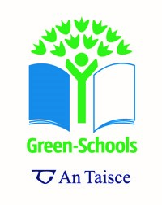  The Linguistics Club  My name is Daria Tcacenko and I am in 2nd year. I joined the linguistics club last year as I am interested in learning about other languages and I wanted to try it out. Language is a means to communicate and if you think about it, all languages are just sets of signs which combine a sequence of letters or sounds with a meaning.  Linguistics is the scientific study of language and its structure and in the Linguistics Club we look at how to study different languages, we find patterns of words and attempt to understand their use and meaning in that language. It trains your logic and allows other people to understand the way people are thinking.  So far, we have looked at puzzles in many different languages such as Norwegian, Phoenician, Swahili and learned a little bit about their structure. These are all practice puzzles for the national linguistics competition that is held every year at the end of January. It is called the All-Ireland Linguistics Olympiad (AILO) and there are many others taking place throughout the world. The top 100 students in Ireland get to compete in the national final and the best 4 out of this group compete in the world Linguistics Olympiad.  Ms Slevin runs the linguistics club and if you are interested in joining or finding out more, contact her. It is open to students from 1st to 6th year and you do not have to be good at languages, just interested in decoding puzzles. Try it out! I think you will enjoy it  TY students Ava Carroll, Hannah Cassidy and Ross Bedford with the TY handmade Christmas cards for the residents and staff of Kilbrew Nursing Home which they delivered to Ashbourne Garda Station on Friday 11th December 2020. They also delivered a thank you letter to the Gardai for all their hard work but especially since COVID-19 19 started. Handwritten letters from the TYs were also handed in for the elderly living in the community. A number of local supermarkets and hospitals also received thank you letters from TYs as well as Deerpark Medical Centre.  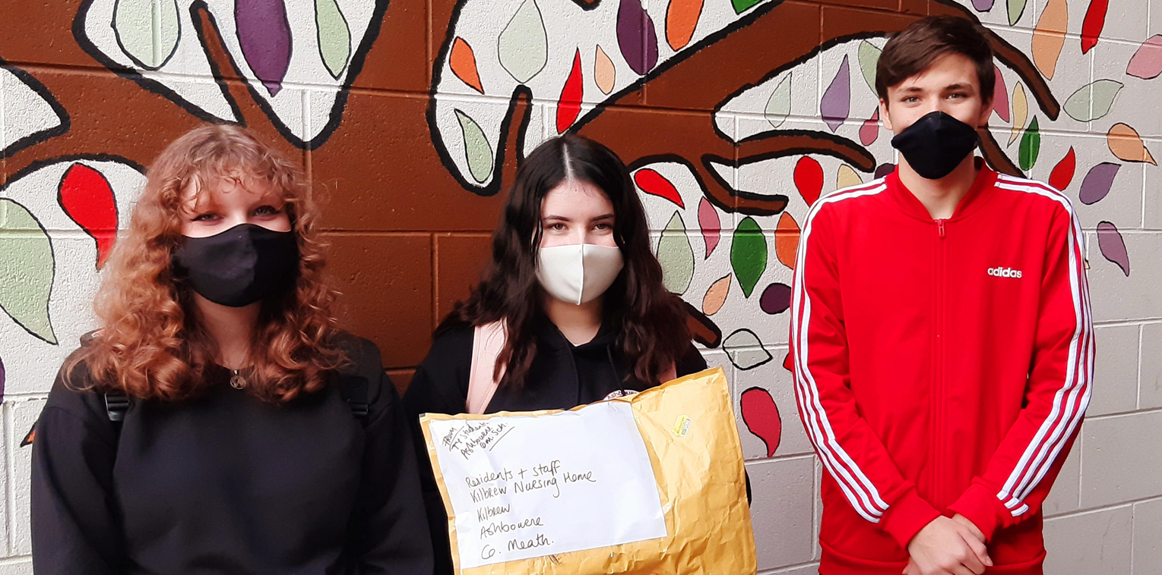  ACS raised €1500 at a Christmas Jumper Day on Wednesday 9th December 2020 for SVP Ashbourne. 80 boxes of food and  gifts were collected by Tadhg Riordan on behalf of SVP Ashbourne on Tuesday 8th December 2020. Thanks to Ms. Mathews 5th year LCVP class who coordinated the food and gift collection and packed it up. Thanks to TY students Filip Kasprzyk, Gabriel Brozek, Niall Moran and Niki Madari who counted and lodged the SVP Christmas Jumper Day collection. 1st year Class O'Farrell also raised money to buy €260 worth of Dunnes Stores vouchers for SVP Ashbourne for those in need in Ashbourne. They did a sponsored silence with Ms. Pike for their CSPE action project. Some staff also collected €300 to buy 15 x €20 Supervalu vouchers for the Ashbourne Senior Citizens Group.  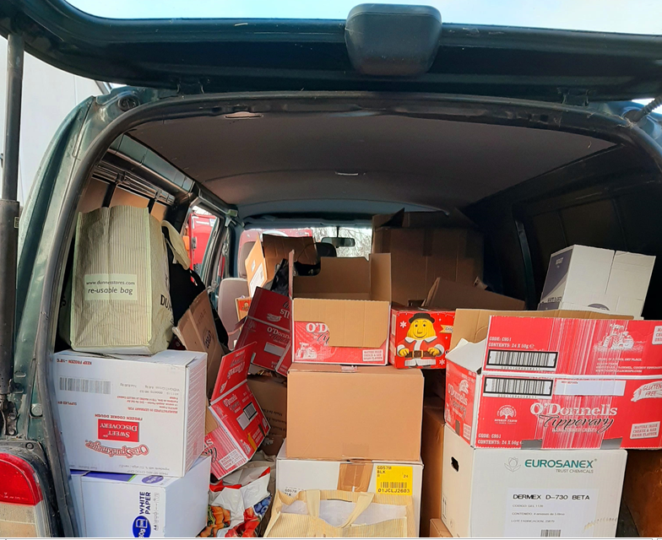 | THE GREEN SCHOOLS COMMITTEE  Green School’s Autumn 2020.  This year’s GS committee, like everything else about 2020, is very different. Part of the fun has always  The Green Schools Committee: -been the mixing of different year groups, which is no longer possible. This year our committee is entirely made up of First year students who have been very impressive in what they have achieved. To date they have created excellent noticeboards and promoted cycling among teenage girls. In Ireland only one out of every 250 teenage girls’ cycle. As part of the current flag on sustainable travel, this is an issue that must be addressed.  A huge thanks goes to Cate Cooney for her starring role in An Taisce’s GS National Travel Conference on November 17th past. Cate was a super confident natural speaker, who got a great response from her audience. As the only student presenter, she was a true ambassador for ACS.  In late October we raised our 8th Green Flag as a socially distanced, COVID-19 aware event. Thanks to retiring Principal Susan Duffy and past pupil James Gibney for their help in raising the flag. Brian Kiernan (2nd year) set this tone for the event with his musical accompaniment. Well done to all involved in achieving Green Flag status once again for ACS.  The Green Schools Committee: -  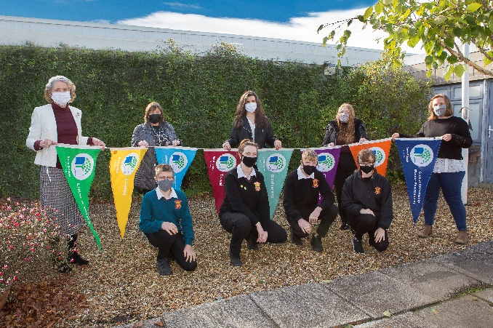  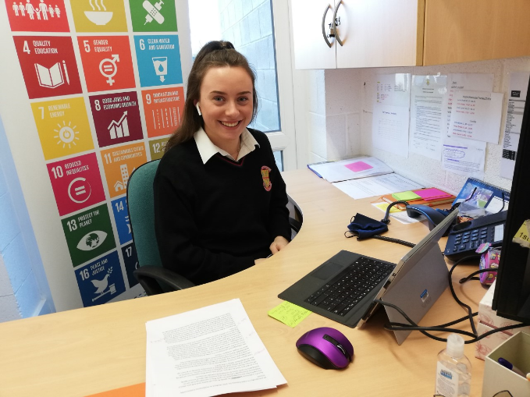  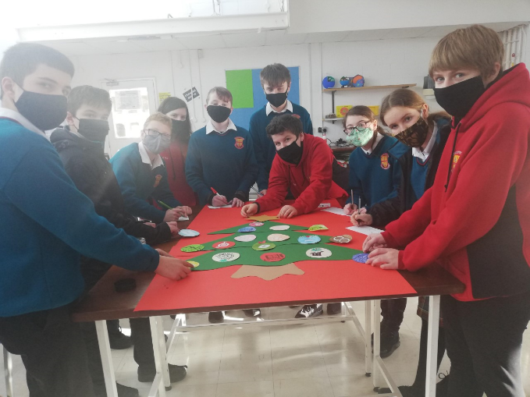  Head Students  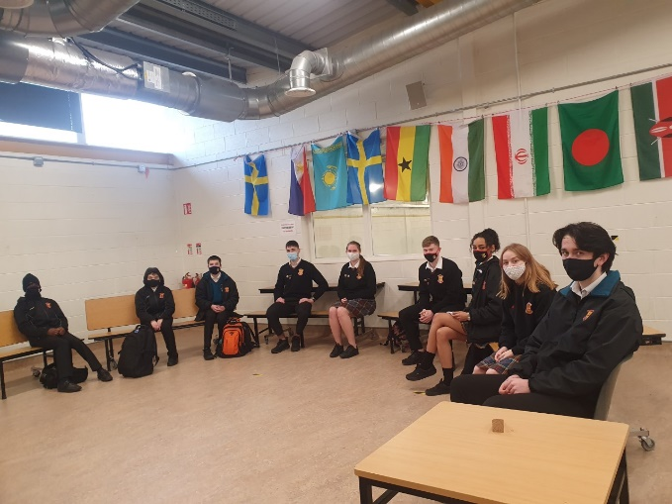  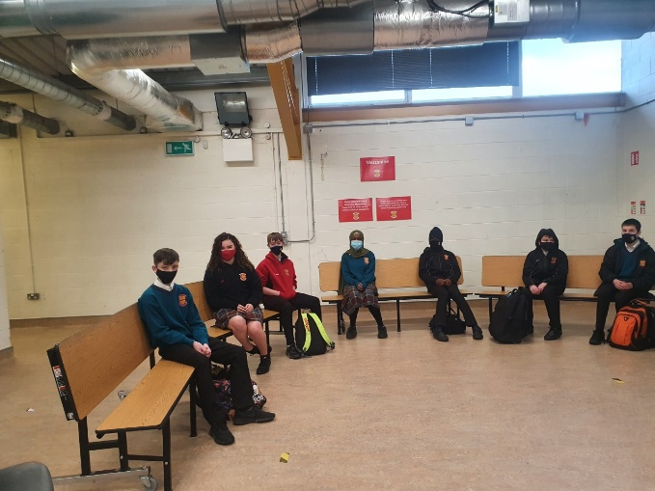  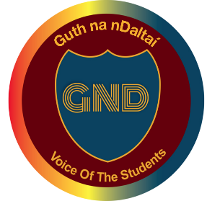  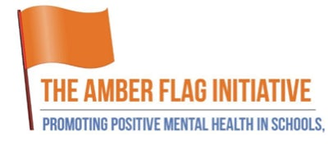  THE AMBER FLAG TEAM  On Thursday 10th December we the Amber flag committee rose the Amber Flag to its pride of place at the entrance to Ashbourne Community school. The flag is a symbol for care and inclusion. It highlights the importance of kindness and always seeking support in times of difficulty. Reaching out is a strength not a weakness. As this year draws to a close, we look forward to the brighter, longer more sunnier times ahead. If anyone would like to join the committee or has any ideas for promoting mental wellbeing please touch base at amberflag@ashcom.ie  SENIOR PREFECTS  The senior prefect's main goal this term was to help the incoming first years settle in and to keep up awareness of safety in the school.  Before everybody’s return to school in September, the senior prefects helped at the first-year introduction day. We were allocated a base class and directed students to their classrooms. We then gave groups of 7 students at a time tours to familiarize them with their new school!  In early October we designed a Halloween themed noticeboard. We decided to incorporate masks into our design. We wanted to show how important it is to wear one during the pandemic and how we can still celebrate Halloween while staying safe.  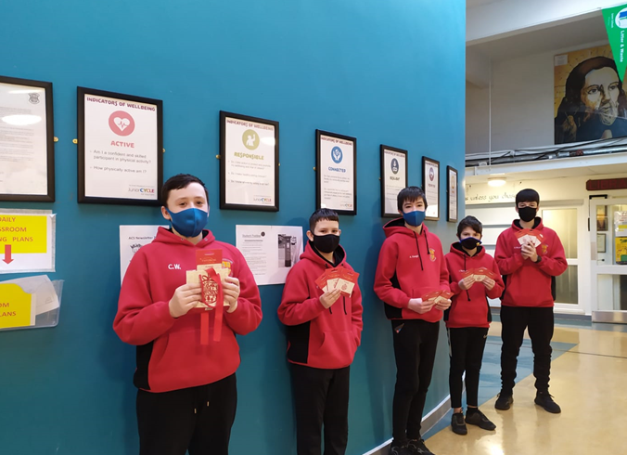
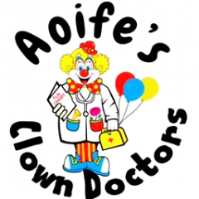  Amy Spratt’s Fundraiser  For the month of November, I set myself a challenge to do 10,000 kick ups to fundraise for ‘Aoife's Clown Doctors’, a charity which is very close to my heart.  ‘Aoife's Clown Doctors’ are professional actors trained to work in hospital settings. They do the most amazing work visiting and entertaining vulnerable and sick children on the wards of many Irish hospitals. Due to COVID-19 19 they hope to continue their work and arrange one to one zoom calls with the children. Aoife loved her visits from the Clown Doctors and spreading smiles is now her legacy.  I know first-hand how important a visit from ‘Aoife's Clown Doctors’ can be. At the age of six, I was diagnosed with Wilms Tumor, and spent over a year in treatment on St. John's Ward in Crumlin Children's Hospital.  While I was there, I got numerous visits from the Clown Doctors and they always knew how to cheer me up, make me smile and brighten my day.  I have lovely memories of their visits and would love other children to experience them too. I completed my challenge and raised €2,510. With the help of everyone's kind donations, Aoife's Clown Doctors can continue to do their amazing work, I hope they can keep spreading laughter and smiles as laughter is the best medicine!  Thank you everyone who donated,  Amy Spratt | For YSI, 8 female TY students made the group ‘Stop the Stigma, periodt’. Our goal is to end gender-based discrimination, spread awareness about pink tax, educate students and individuals. We want to ultimately stop the stigma around menstruation.  Pink tax is the extra money women must pay for many products, even if it’s the exact same as the men’s version. As part of our project, we hope to install sanitary dispensers and free sanitary products in the female bathrooms in our school. We also plan on making a podcast, hopefully on Spotify. This will be to raise awareness on exactly what pink tax is and destigmatizing periods. A raffle will be officially announced soon, and we have a wide range of prizes to be won, so be sure to keep an eye out! All funds made will be donated directly to Meath’s Women Refuge and Support Services.  Young Social Innovators Cont.  Our Instagram is @stopthestigma.periodt where we are constantly trying to educate others and give updates on our project.

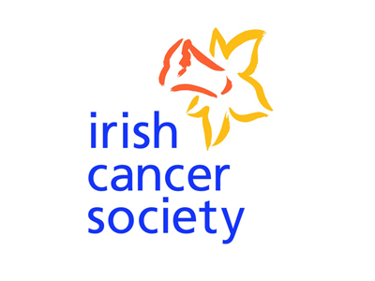
Tom O’Hara’s Fundraiser
My name is Tom O’Hara and on the 10th of December myself and 42 of my peers ran a total of 66 kilometers for the National Cancer Society. Each student who took part ran just over a kilometer. To date we have raised €1180, which is over double my target of €500. The support we received from the school and the staff was incredible, so many teachers helped me organize the run and countless others donated to my iDonate page. I’d like to thank the school for backing my idea and everyone else who helped me on the day. I really enjoyed organizing this event and I hope that this isn’t the one I do.

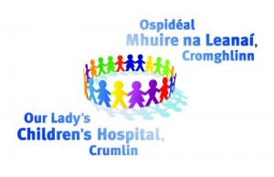
Emma Mather’s Fundraiser

Myself and my mam took part in CMRF Crumlin’s fundraiser 150km Your Way, 150,000 children a year passed through the doors of Our Lady’s Children’s Hospital, Crumlin. Over the month of November, we did 5km each and every day. By the end of the month, we had well over 300km done between the two of us and we raised over €900 for this amazing charity we hold very close to our hearts. I have been a patient of Our Lady’s Children’s Hospital, Crumlin for 18 years as I was diagnosed with a rare heart condition at birth. I am being transferred to the Mater now I wanted to do something small to give back to all the amazing doctors, nurses and staff that never fail to put a smile on your face.
During these difficult times it was amazing to see the support and well wishes everyone was giving us. Doing something as walking 5km a day and raising funds is going to save a child’s life and make their time in hospital that little bit better.
The link to donate:
https://www.justgiving.com/fundraising/aileen-mather?utm_source=facebook&utm_medium=fundraising&utm_content=aileen-mather&utm_campaign=pfp-share&utm_term=5be0d3894b6141e1a1d9e1f31c6d6382&fbclid=IwAR122JHHP--nKzkltUR5BUgFaLsWG-jziH9gjAh55V815JmXwDQXsA82X6U

Covid-19

"if you know yourself and know the enemy, you need not fear the results of a thousand battles
if you know yourself but not the enemy, every victory you have will also suffer a defeat"
-sun tzu, the art of war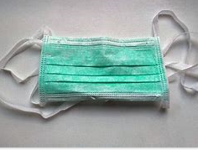
Shop local, spend local, enjoy local
This year, many of us may have been forced to shop closer to home. We have experienced the many joys of shopping locally. Going local does not mean closing off all other options in the outside world, but it does mean nurturing locally owned businesses that use local resources, employ local workers and serve primarily local consumers. This said, the benefits of shopping close to home can be far more extensive than you may realise - particularly if you make a habit out of it. In fact, according to Visa, almost half of all small business owners say that everyone just spent a fiver extra per week, it could help them stay open in the long term.
By shopping local, you are creating jobs, keeping money in the local economy, investing in entrepreneurship, nurturing a sense of community and supporting the environment by reducing waste and conserving energy.
Christmas shopping is one of the festive seasons' most time-honoured traditions. Last year, the average household in Ireland spent nearly three thousand euros on gifts. Something to keep in my mind when deciding where to pick up your bits for Christmas shopping is that, when you buy from a small business, you are not helping a billionaire CEO to buy a third holiday home - but you are helping that little child get dance lessons, or the new GAA jersey, helping a busy parent put food on the table or helping a student pay for college.
Róisín Moss, TY Journalist

Merry Christmas to Students and Staff
From Head Students

